EXPERIMENT
Student Name: Yashraj UID:22BET10240
Branch: BE -IT Section/Group:22BET_IOT-702-A
Semester: 6th Subject Code: 22ITP-351
PROBLEM-1
AIM:-
Print linked list
CODE:-

class Node {
int data;
Node next;
Node(int data) {
this.data = data;
this.next = null;
}
}

class Solution {
void printList(Node head) {
Node temp = head;
while (temp != null) {
System.out.print(temp.data + " ");
temp = temp.next;
}
System.out.println();
}
}

public class Main {
public static void main(String[] args) {
Node head = new Node(49);
head.next = new Node(10);
head.next.next = new Node(30);

Solution sol = new Solution();
sol.printList(head);
}
}

OUTPUT:-
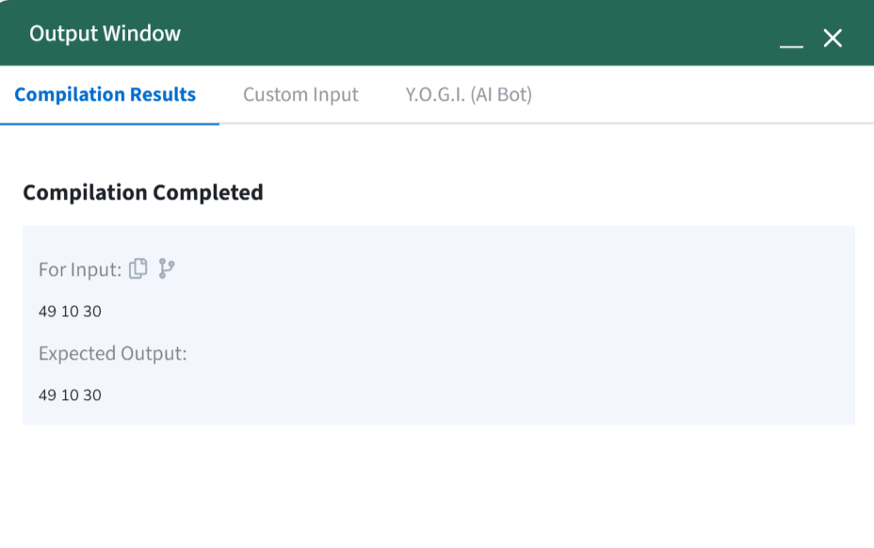PROBLEM-2
AIM:-
Remove duplicates from a sorted list
CODE:-
class Solution {
public ListNode deleteDuplicates(ListNode head) {
ListNode res = head;

while (head != null && head.next != null) {
if (head.val == head.next.val) {
head.next = head.next.next;
} else {
head = head.next;
}
}

return res;
}
}

OUTPUT:-
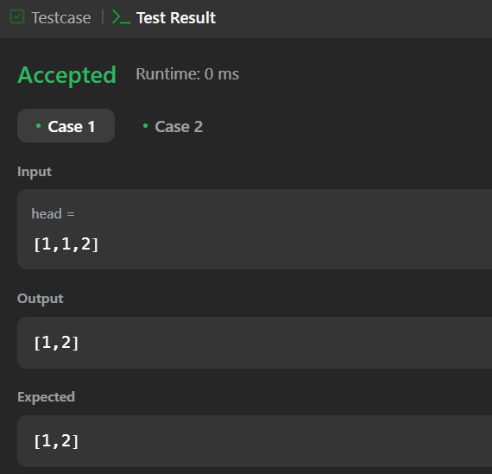
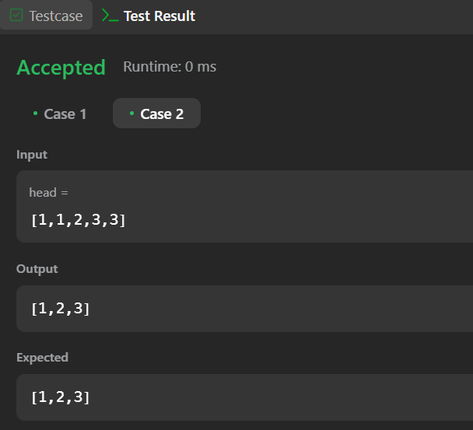
PROBLEM-3
AIM:-
Reverse a linked list
CODE:-
class Solution {
public ListNode reverseList(ListNode head) {
ListNode node = null;

while (head != null) {
ListNode temp = head.next;
head.next = node;
node = head;
head = temp;
}

return node;
}
}

OUTPUT:-
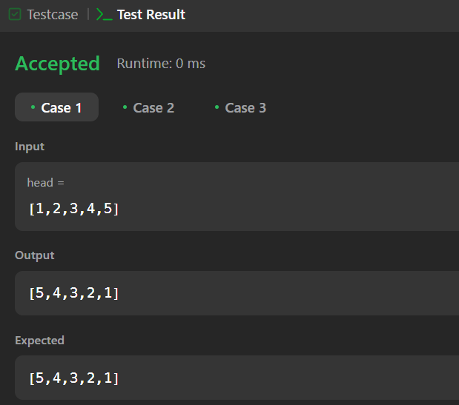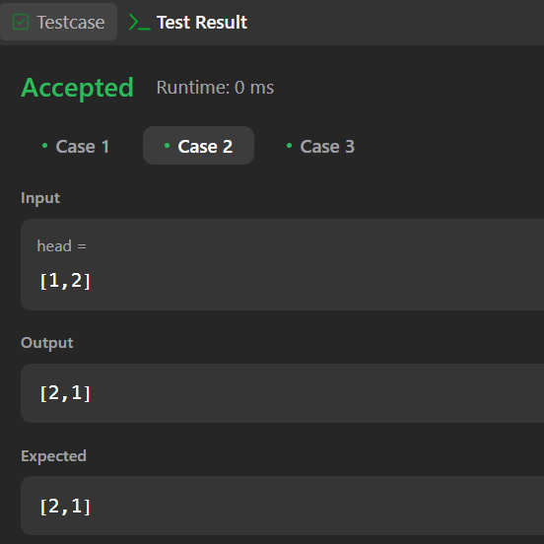
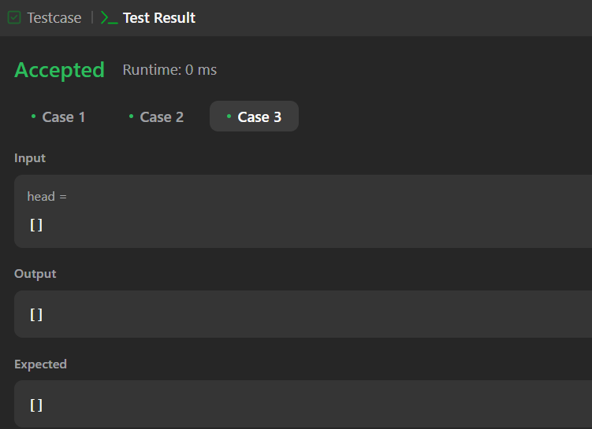

PROBLEM-4
AIM:-
Delete middle node of a list
CODE:-
class Solution {
public ListNode deleteMiddle(ListNode head) {
ListNode counter = head;
int count = 0;
while(counter != null){
counter = counter.next;
count++;
}
ListNode curr = head;
if(count == 1){
return curr.next;
}
int middle = (count/2) - 1;
count = 0;
while(count != middle){
curr = curr.next;
count++;
}
curr.next = curr.next.next;
return head;
}
}
OUTPUT:-
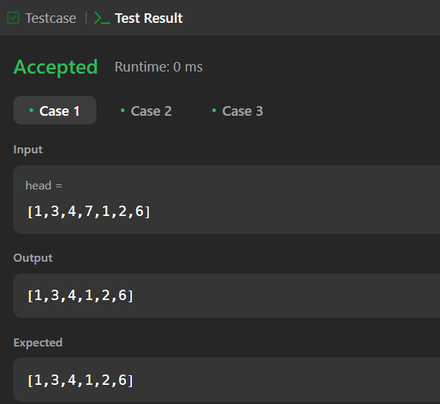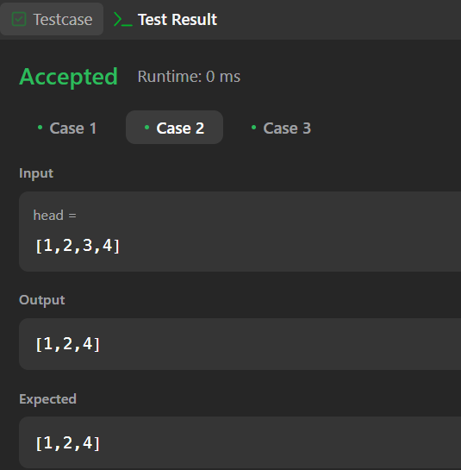
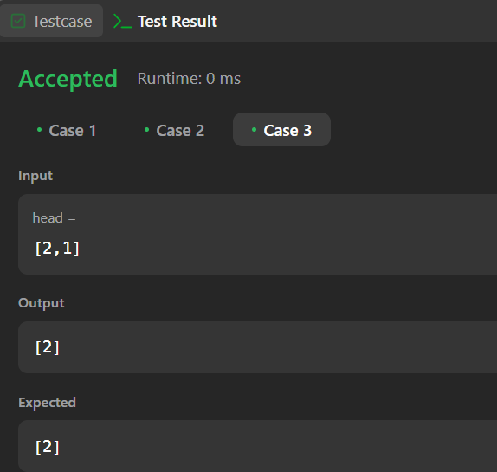
PROBLEM-5
AIM:-
Merge two sorted linked lists
CODE:-
class Solution {
public ListNode mergeTwoLists(ListNode list1, ListNode list2) {
ListNode dummy = new ListNode();
ListNode cur = dummy;

while (list1 != null && list2 != null) {
if (list1.val > list2.val) {
cur.next = list2;
list2 = list2.next;
} else {
cur.next = list1;
list1 = list1.next;
}
cur = cur.next;
}

cur.next = (list1 != null) ? list1 : list2;

return dummy.next;
}
}
OUTPUT:-
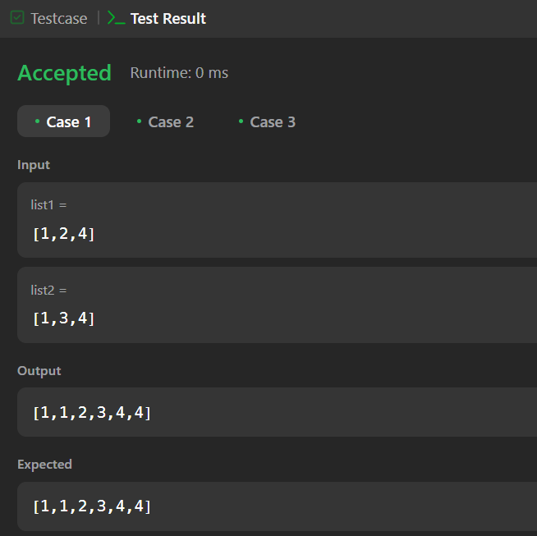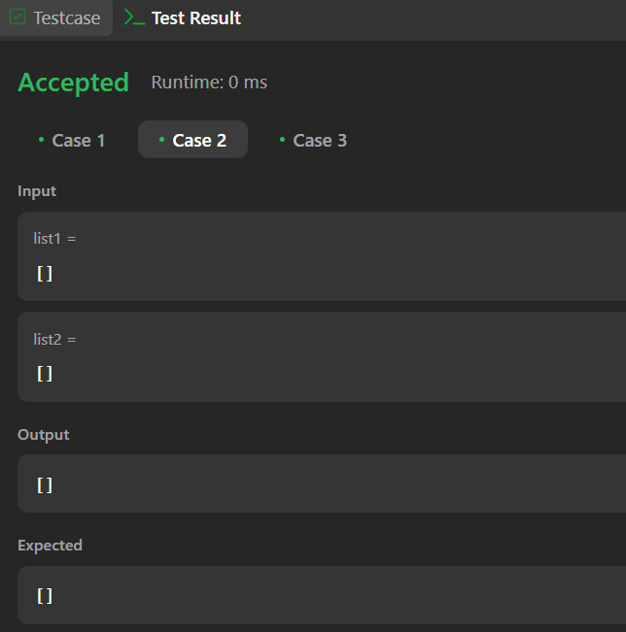
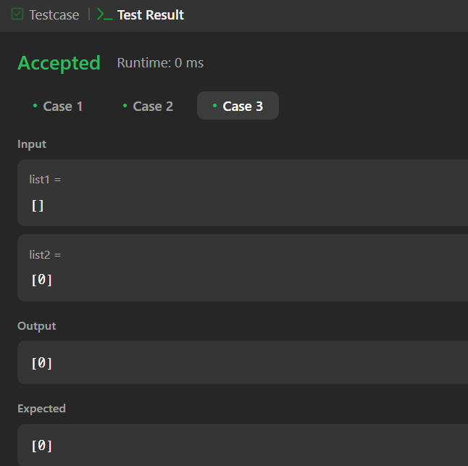
PROBLEM-6
AIM:-
Remove duplicates from sorted lists 2
CODE:-
class Solution {
public ListNode deleteDuplicates(ListNode head) {
ListNode ans = new ListNode(1000, head);
ListNode cur = ans;

while (cur.next != null && cur.next.next != null) {
if (cur.next.val == cur.next.next.val) {
int val = cur.next.val;
while (cur.next != null && cur.next.val == val) {
cur.next = cur.next.next;
}
} else {
cur = cur.next;
}
}

return ans.next;
}
}
OUTPUT:-
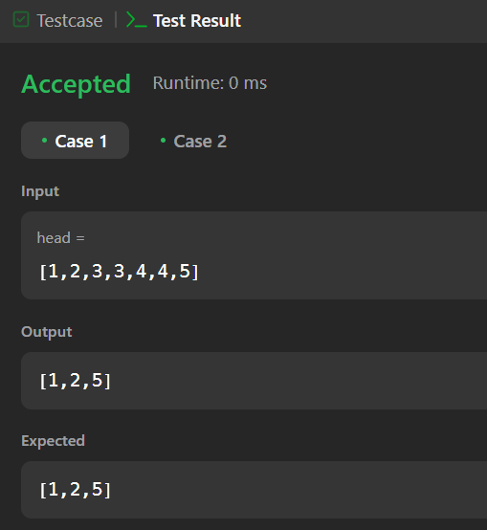
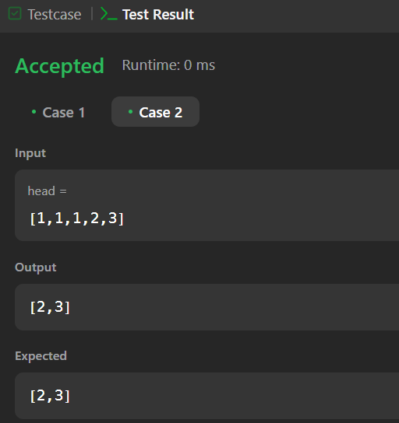
PROBLEM-7
AIM:-
Detect a cycle in a linked list
CODE:-
public class Solution {
public boolean hasCycle(ListNode head) {
ListNode fast = head;
ListNode slow = head;

while (fast != null && fast.next != null) {
fast = fast.next.next;
slow = slow.next;

if (fast == slow) {
return true;
}
}

return false;
}
}
OUTPUT:-

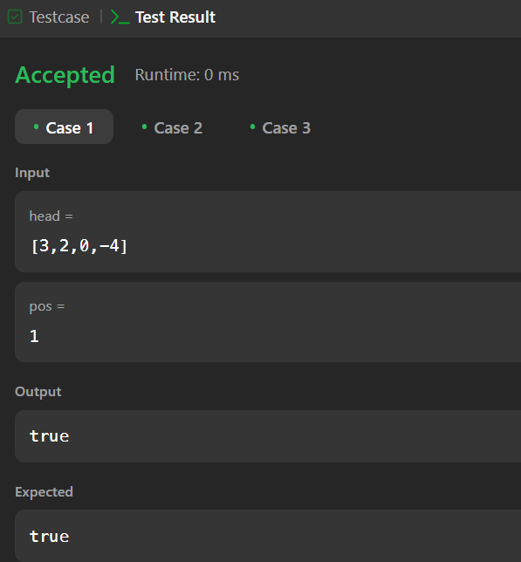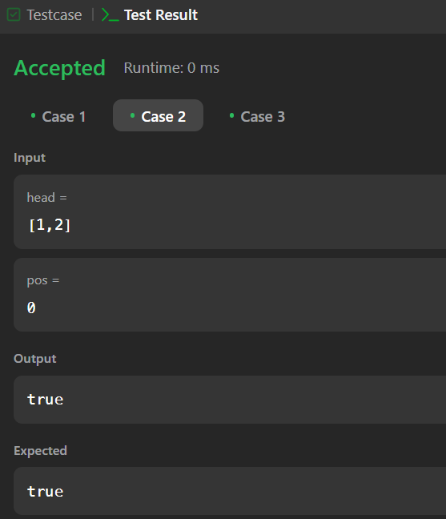
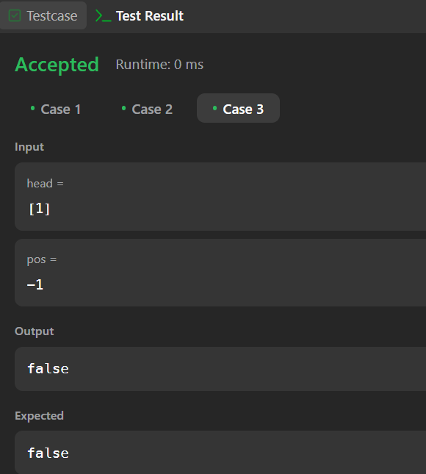
PROBLEM-8
AIM:-
Reverse linked list 2
CODE:-
class Solution {
public ListNode reverseBetween(ListNode head, int left, int right) {
if (head == null || left == right) {
return head;
}
ListNode dummy = new ListNode(0);
dummy.next = head;
ListNode prev = dummy;
for (int i = 0; i < left - 1; i++) {
prev = prev.next;
}
ListNode cur = prev.next;
for (int i = 0; i < right - left; i++) {
ListNode temp = cur.next;
cur.next = temp.next;
temp.next = prev.next;
prev.next = temp;
}
return dummy.next;
}
}
OUTPUT:-
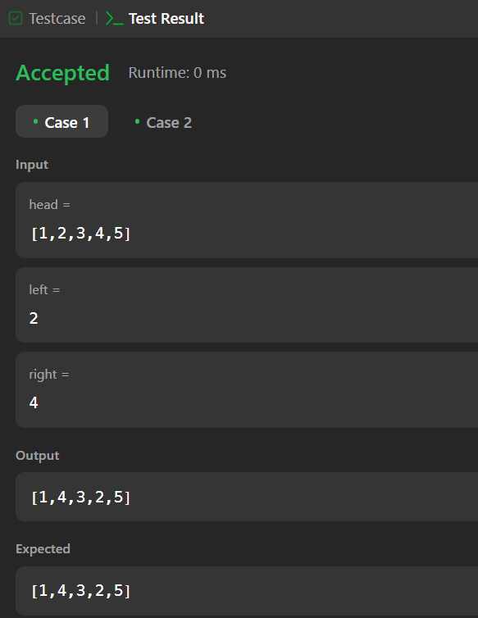
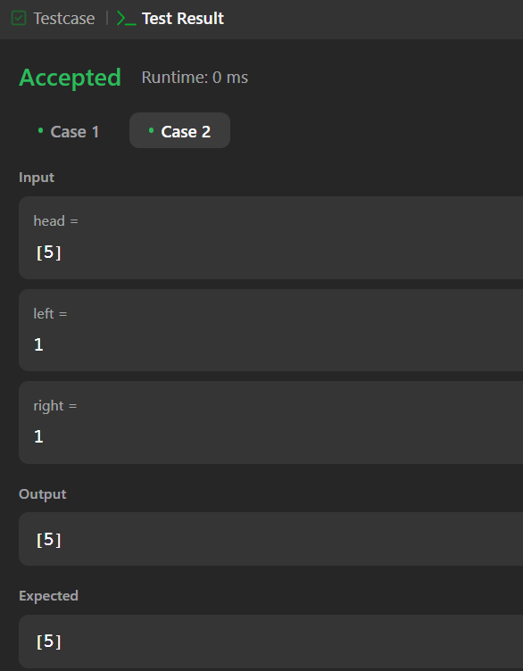
PROBLEM-9
AIM:-
Rotate a list
CODE:-
class Solution {
public ListNode rotateRight(ListNode head, int k) {
if (head == null || head.next == null || k == 0) {
return head;
}
int length = 1;
ListNode temp = head;
while (temp.next != null) {
temp = temp.next;
length++;
}
temp.next = head;
k = k % length;
k = length - k;
while (k-- > 0) {
temp = temp.next;
}
head = temp.next;
temp.next = null;
return head;
}
}
OUTPUT:-
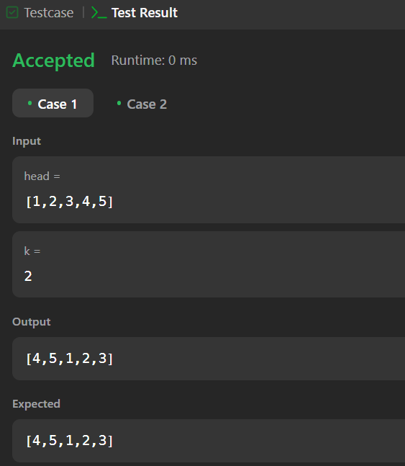
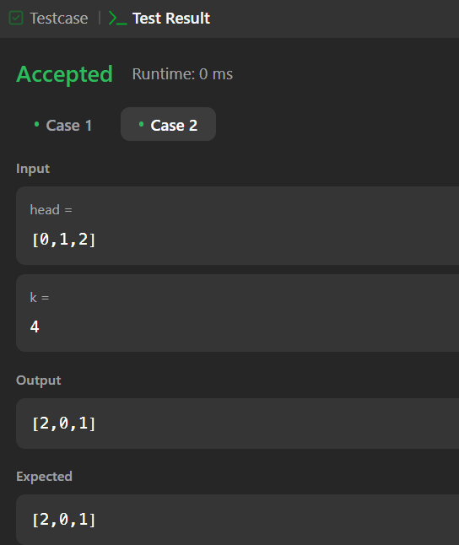
PROBLEM-10
AIM:-
Merge k sorted lists
CODE:-
class Solution {
public ListNode mergeKLists(ListNode[] lists) {
if (lists == null || lists.length == 0) {
return null;
}
return mergeKListsHelper(lists, 0, lists.length - 1);
}

private ListNode mergeKListsHelper(ListNode[] lists, int start, int end) {
if (start == end) {
return lists[start];
}
if (start + 1 == end) {
return merge(lists[start], lists[end]);
}
int mid = start + (end - start) / 2;
ListNode left = mergeKListsHelper(lists, start, mid);
ListNode right = mergeKListsHelper(lists, mid + 1, end);
return merge(left, right);
}

private ListNode merge(ListNode l1, ListNode l2) {
ListNode dummy = new ListNode(0);
ListNode curr = dummy;

while (l1 != null && l2 != null) {
if (l1.val < l2.val) {
curr.next = l1;
l1 = l1.next;
} else {
curr.next = l2;
l2 = l2.next;
}
curr = curr.next;
}
curr.next = (l1 != null) ? l1 : l2;
return dummy.next;
}
}
OUTPUT:-
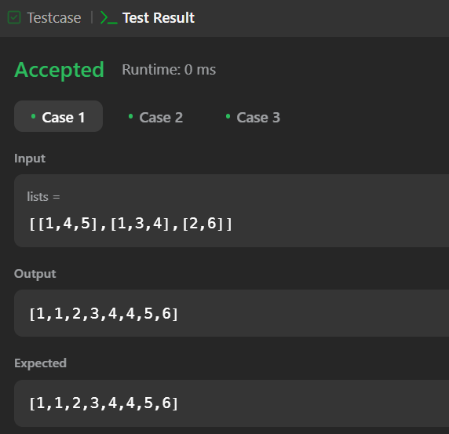

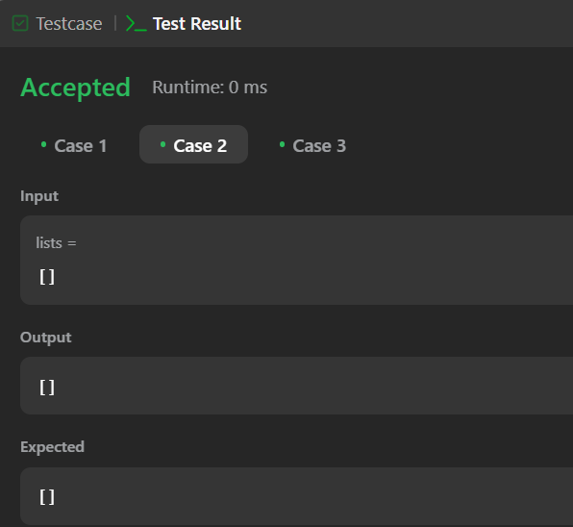

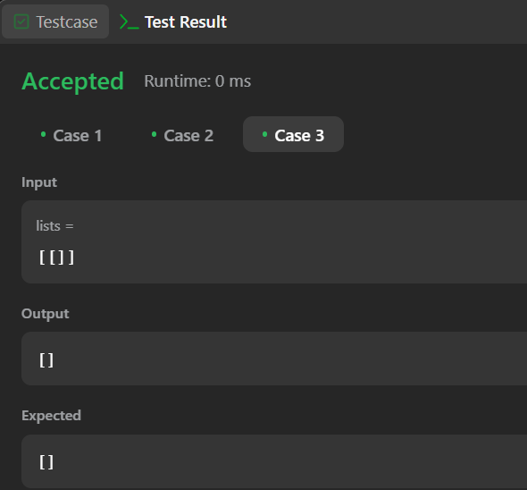
PROBLEM-11
AIM:-
Sort List
CODE:-
class Solution {
public ListNode sortList(ListNode head) {
if (head == null || head.next == null) return head;
ListNode slow = head, fast = head.next;
while (fast != null && fast.next != null) {
slow = slow.next;
fast = fast.next.next;
}

ListNode mid = slow.next;
slow.next = null;
ListNode left = sortList(head);
ListNode right = sortList(mid);
return merge(left, right);
}
private ListNode merge(ListNode l1, ListNode l2) {
ListNode dummy = new ListNode(0);
ListNode tail = dummy;

while (l1 != null && l2 != null) {
if (l1.val < l2.val) {
tail.next = l1;
l1 = l1.next;
} else {
tail.next = l2;
l2 = l2.next;
}
tail = tail.next;
}

tail.next = (l1 != null) ? l1 : l2;
return dummy.next;
}
}

OUTPUT:-
